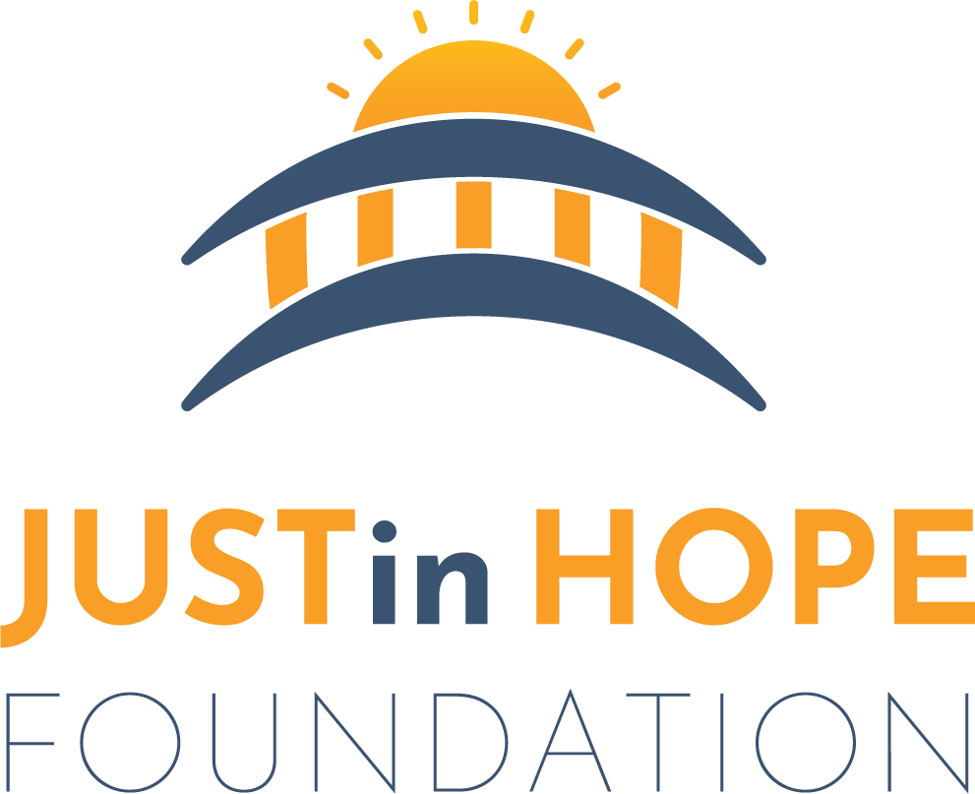 Autism/ Intellectual and Developmental Disabilities Registration Form
For First Responders

Person’s Name: ___________________________________________________ DOB: ___________________________
Race: _________________ Gender: ___________ Height: ______________ Weight: _________________________
Hair: _____________ Eyes: ______________ Scars/Birthmarks/Tattoos: ______________________________
Home Address:______________________________________________________________________________________
Home Phone: ______________________________________________ Cell: ___________________________________

Primary Diagnosis: _______________________________________________________________________________
Prone to Seizures? _______Yes ________No Level of Communication: _______ High _______Low _______Non-Verbal
If non-verbal, mode of communication: __________________________________________________________
Will this person respond to name being called? _______Yes _______No
Medications: ________________________________________________________________________________________
Allergies to Medications: ___________________________________________________________________________
Prior Wandering Incident? _______Yes _______No
If yes, where has this person been located before?______________________________________________
Closest water to residence: ________________________________________________________________________
List all lakes, ponds, streams, drainage ponds, etc., in the area: ________________________________
________________________________________________________________________________________________________
Favorite hiding place at home: ____________________________________________________________________
Favorite place in neighborhood/community: ____________________________________________________
Sensory Issues: _______Yes _______No Touch: ______Yes ______No Sounds: _____Yes _____No
Bright Lights: _______Yes _______No Eye Contact: _______Yes _______No
Processing Delays: _______Yes _______No Aggression: _______Yes _______No
Stimming Behavior:_________________________________________________________________________________
Fears: ________________________________________________________________________________________________
Dislikes/Triggers: __________________________________________________________________________________
Favorite Objects/Topics: ___________________________________________________________________________
Pre-meltdown Signs: ____________________________________________________
Meltdown Behavior: _______________________________________________
Calming Strategies: _________________________________________________________________________________
Weapons in the Home? _______Yes _______No Weapons Secured? _______Yes _______ No
Are restraints used by caretakers for safety? _______Yes _______No
Any other information you feel is pertinent to person at risk: _________________________________
________________________________________________________________________________________________________
Emergency Contacts

1. Name: ___________________________________________________ Relationship: _________________________
Address: _____________________________________________________________________________________________
Phone: ___________________________________________ Cell: _____________________________________________
2. Name: ___________________________________________________ Relationship: _________________________
Address: _____________________________________________________________________________________________
Phone: ___________________________________________ Cell: _____________________________________________

I, ___________________________________________________, hereby give my permission for any first responder agency (including but not limited to: police, fire, rescue, EMS, 911 Dispatch Center, search and rescue personnel) to retain and distribute the information contained in this registration form to other first responder personnel for the sole purpose of identification and protection of the person identified above in an emergency or crisis situation.

Name of person/guardian completing form: _____________________________________________________

Signature: ____________________________________________________ Date: ________________________________

Email Address: ______________________________________________________________________________________

Please email completed form to info@justinhope.org or mail it to 2590 Orovada Street, Reno, NV 89512. Please call (775) 453-9262 if you have any questions or need assistance.

*Portions for information on this form were taken from ASET (Autism Safety Education & Training). We are thankful for their contribution.

